How to configure a database in to Logshipping

Step 1: take the full backup and trn log backup in primary

Step 2 : Stop the Commvault three backup jobs

Step 3: Restore the above in No Recovery mode

Step 4: Go to database logshipping properties in primary database and configure the settings as per the another database settings

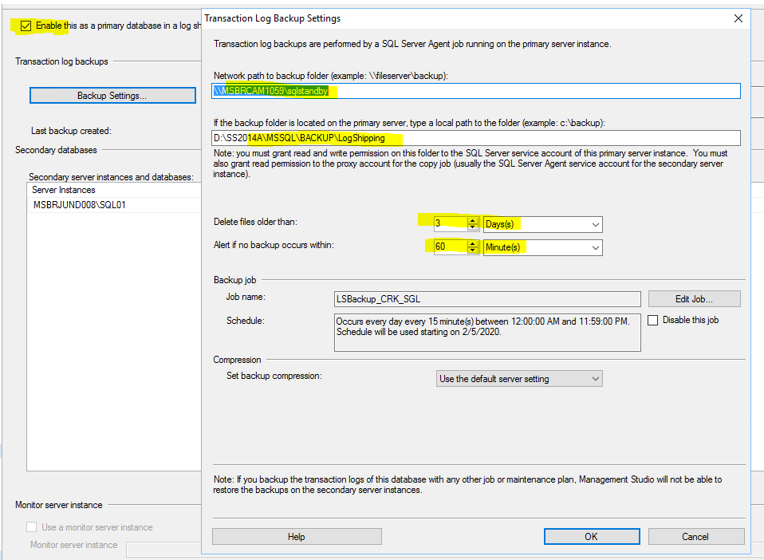

Step : 5 click on this … and provide the settings

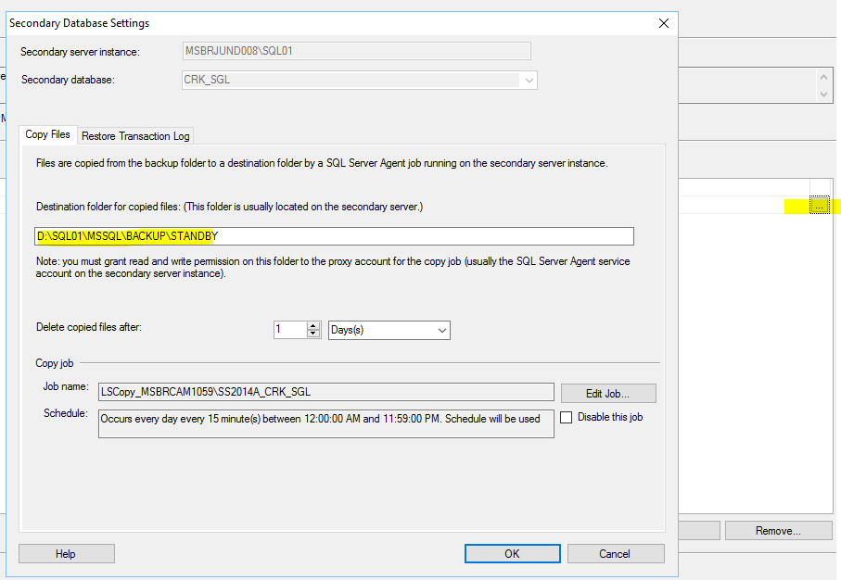

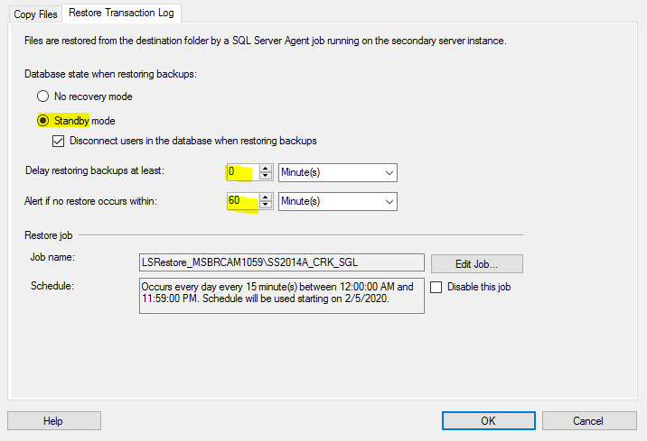

Step 6: there is one backup job created in primary and two jobs (Copy and Restore jobs in secondary)

Step 7: go to instance -> Standard reports -> transaction logshipping status ( it should show good there)

Step 8 : V.V IMP Please enable the CM jobs once configured